**PIZZA SALES SQL QUERIES:**

1. **KPI’S:**
2. **Total Revenue:**

select sum(total_price) [Total Revenue] from [dbo].[pizza_sales]

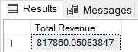

1. Average order value:

select sum(total_price)/count(distinct(order_id)) from [dbo].[pizza_sales]



1. **Total pizza sold:**

select sum(quantity) [Total pizza sold] from dbo.pizza_sales



1. **Total Orders:**

select count(distinct(order_id)) [Total Orders] from [dbo].[pizza_sales]



1. **Average pizzas per order:**

select cast(cast(sum(quantity) as DECIMAL(10,2))/ cast(count(distinct(order_id)) as DECIMAL(10,2)) as DECIMAL(10,2)) as [Average pizzas per order] from [dbo].[pizza_sales]



1. **Chart Requirement:**
2. **Daily Trend for Total Orders:**

select DATENAME(DW,order_date) as order_day, count(distinct order_id) as Total_order from [dbo].[pizza_sales] group by DATENAME(DW,order_date)

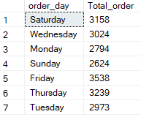

1. **Monthly Trend for Total orders:**

select DATENAME(MM,order_date) as order_Month, count(distinct order_id) as Total_order from [dbo].[pizza_sales] group by DATENAME(MM,order_date)

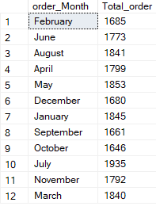

1. **Percentage of sales by Pizza category:**

WITH pizza_total_sales AS (

select sum(total_price) as pizza_total_sales from [dbo].[pizza_sales]

)

select pizza_category pizza_category, cast ((sum(total_price) / (select pizza_total_sales from pizza_total_sales)) * 100 as decimal (10,2)) as sales_percentage from [dbo].[pizza_sales]

group by pizza_category;

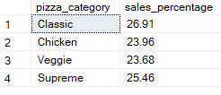

**4.Percentage of Sales by Pizza Size:**

WITH pizza_total_sales AS (

select sum(total_price) as pizza_total_sales from [dbo].[pizza_sales]

)

select pizza_size, cast((sum(total_price) / (select pizza_total_sales from pizza_total_sales)) * 100 as decimal(10,2)) as sales_percentage from [dbo].[pizza_sales]

group by pizza_size order by pizza_size;

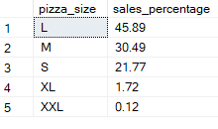

**5.Total Pizzas Sold by Pizza Category:**

select pizza_category, sum(quantity) Total_pizza_sold from [dbo].[pizza_sales] group by pizza_category;

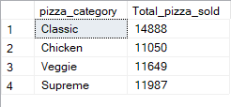

1. **Top 5 Best Sellers by Revenue:**

select Top 5 pizza_name, sum(total_price) as Total_revenue from dbo.pizza_sales

group by pizza_name order by Total_revenue desc

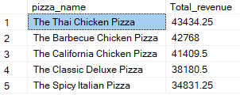

1. **Top 5 Best Sellers by Total Quantity:**

select Top 5 pizza_name, sum(quantity) as Total_qty from dbo.pizza_sales

group by pizza_name order by Total_qty desc

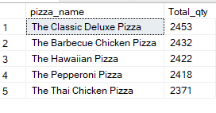

1. **Top 5 Best Sellers by Total Quantity:**

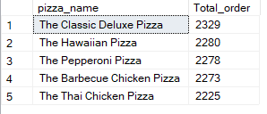

1. **Bottom 5 Best Sellers by Revenue:**

select Top 5 pizza_name, sum(total_price) as Total_revenue from dbo.pizza_sales

group by pizza_name order by Total_revenue asc

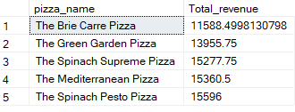

1. **Bottom 5 Best Sellers by Total Quantity:**

select Top 5 pizza_name, sum(quantity) as Total_qty from dbo.pizza_sales

group by pizza_name order by Total_qty asc

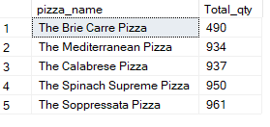

1. **Bottom 5 Best Sellers by Total Quantity:**

select Top 5 pizza_name, count(distinct(order_id)) as Total_order from dbo.pizza_sales group by pizza_name order by Total_order asc

